BREAKFAST & BRUNCH
- Breakfast served from 9.30am to noon at our restaurants every day
- Make your weekend special! Every Saturday we serve, Aqua's brunch & bottomless brunch till 4pm. 2 courses & free flowing prosecco, bellinis, bloody mary's & peroni between 9.30am & 4pm, just £22. A 2 hour time limit applies and some locations licenses vary on sale of alcohol.
- Go to top

BREAKFAST
Gluten free bread is available on request
  - Aqua Breakfast
Pork farmhouse sausage, Suffolk sweet cured bacon, portobello mushroom, vine ripened tomatoes, black pudding, poached egg & baked beans with toasted sourdough bread
8.5
  - Aqua Veggie Breakfast
Grilled asiago, avocado, poached eggs, sauteed potatoes, portobello mushroom, roast tomatoes & baked beans
8
- Go to top

EGGS
  - Toast & Jam
Sourdough or gluten-free
2
  - Brioche Sausage Bun
Pork farmhouse sausage served in a brioche bun
5
  - Brioche Bacon & Egg Bun
Sweet cured bacon with a hens fried egg served in a brioche bun
5
  - Eggs Benedict
Poached eggs with crisp pancetta & creamy hollandaise on a toasted muffin
6.5
  - Eggs Royale
Smoked salmon, poached eggs, toasted muffins with hollandaise sauce
7
  - Scrambled Eggs & Smoked Salmon
Served on sourdough toast
7
  - Avocado & Spinach Benedict
Avocado, spinach, poached eggs on toasted muffin with a hollandaise sauce
7
  - Eggs Pomodoro
Oven baked bloomer bread with wilted spinach, poached eggs, topped with tomato & basil sauce & parmesan
6.5
  - Aqua's Eggs
Scrambled, poached or fried with sourdough toast
5.5
  - Avocado & Eggs on Toast
Lime & chilli avocado & poached eggs
7
  - Homemade Pancakes
With blueberries, strawberries, mascarpone & maple syrup
4.5
- Go to top

COFFEE & TEA
Our coffee is sourced direct from Finca Buena Vista, El Salvador. It’s a Single origin, with notes of Rum & Raisin, Walnut, & Cocoa
  - Espresso
2.2
  - Espresso Macchiato
2.2
  - Double Espresso
2.6
  - Americano
2.4
  - Cappuccino
2.6
  - Latte
2.6
  - Flat white
2.6
  - Hot chocolate
2.6
  - Selection of teas
2.2
  - Baileys iced coffee
5
Add a syrup to your coffee; vanilla or salted caramel 50p extra
- Go to top

SOFT DRINKS
  - Acqua Pana Still Water
4.3
  - San Pellegrino Sparkling Water
4.3
  - San Pellegrino Aranciata
2.8
  - San Pellegrino Limonata
2.8
  - Luscombe Hot Ginger Beer
2.8
  - Luscombe Wild Elderflower Bubbly
2.8
  - Selection of Fresh Juices
2.5

SUNDAY ROAST
- 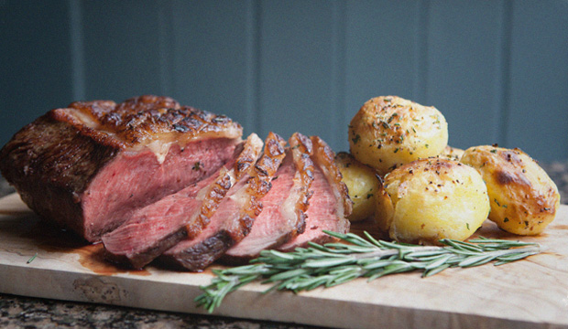
- Make Sundays special with our traditional Sunday roasts.
› A choice of striploin of beef, slow roast porchetta or chicken
› Homemade Yorkshire pudding
› Roast potatoes
› Seasonal vegetables
› All the trimmings
Just 12.5 all day Sunday
2 Courses 15.5 | 3 Courses 18.5

