TO NIBBLE & SHARE

NOCELLARA OLIVES (v)
£2.95

ARTISAN RUSTIC BREADS
with olive oil & balsamic vinegar, Nocellara olives and flavoured butter (v)
£5.95

GARLIC PIZZETTE
with rocket & shaved Gran Moravia cheese (v)
£6.95

CARNE PLATTER
Southern-fried buttermilk chicken thighs, lamb koftas, crispy sweet chilli beef, spiralised carrot salad, and pork & fennel sausage topped flatbread
£16.95

BOX-BAKED CAMEMBERT
topped with omega seed sprinkle, cherry & thyme dip and warm dough sticks (v)
£12.50
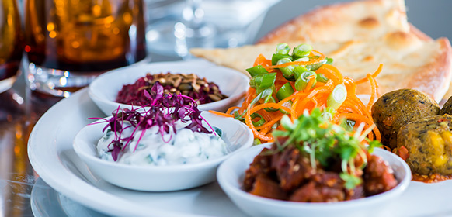

MEZZE PLATTER
roasted lentil falafels, beetroot hummus with omega seed sprinkle, miso sesame glazed aubergine, Lebanese-style dip, spiralised carrot salad, coconut tzatziki and flatbread (ve)
£12.95

STARTERS

SCALLOPS OF THE DAY

SOUP OF THE DAY (V)
in Devon crab crème fraiche with toasted ciabatta bread
£5.25

LOBSTER & KING PRAWN POT
in Devon crab crème fraiche with toasted ciabatta bread
£8.25

THYME-ROASTED PORTOBELLO MUSHROOMS
in Cropwell Bishop sauce with rustic toast (v)
£6.95
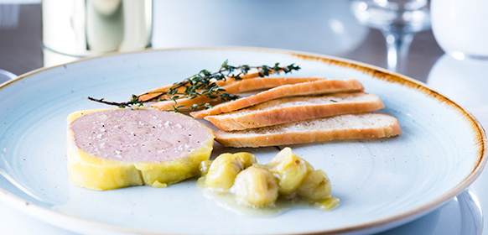

DUCK LIVER & PORT PARFAIT
with gooseberry & Prosecco flavour compote and toasted ciabatta bread
£7.75

DEEP-FRIED BRIE
in panko breadcrumbs with chutney (v)
£6.50

SWEET CHILLI KING PRAWN ROLL
with julienne vegetables, chilli & coriander, wrapped in rice paper, with a sweet chilli & soy dipping sauce
£6.95

CRISPY KARAAGE CHICKEN
with cucumber ribbons, mooli, kale & cauliflower couscous salad and warm katsu sauce
£6.95

CHARGRILLED LAMB KOFTAS
Goats’ curd, plum tomato, roasted red pepper, cucumber & mint salad
£6.95

SALT & SZECHUAN PEPPER SQUID
with aioli
£6.95

SALADS

CHICKEN, BACON & AVOCADO SALAD
with baby kale, spinach and Tenderstem broccoli with a cider & honey mustard dressing
£13.50
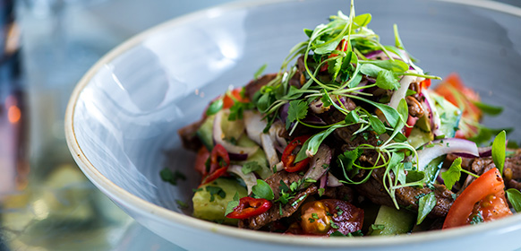

STIR FRIED BEEF FILLET SALAD
with cucumber, tomato, red onion, spring onions, coriander, red chilli, and a soy, lime & lemongrass dressing
£13.50

WHOLEFOOD SALAD
Kale & cauliflower couscous, asparagus, Tenderstem broccoli, avocado, butternut squash, sweet potato, pomegranate and roasted pumpkin seeds with a pineapple ,lemongrass & ginger dressing
£10.50

ROASTS
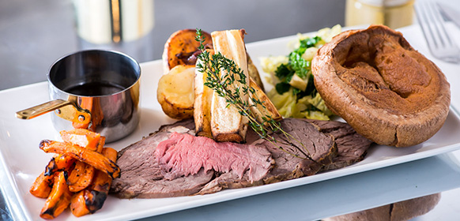

ROAST RIB OF BEEF
with coarse-grain mustard seasoning. Served with smoked beef-dripping roasted potatoes, seasonal greens & roasted roots, Yorkshire pudding & bottomless gravy.
£15.95

ROAST PORK LOIN
with crackling, and stuffing wrapped in bacon. Served with smoked beef-dripping roasted potatoes, seasonal greens & roasted roots, Yorkshire pudding & bottomless gravy.
£13.95

ROAST CHICKEN
with bread sauce and stuffing wrapped in bacon. Served with smoked beef-dripping roasted potatoes, seasonal greens & roasted roots, Yorkshire pudding & bottomless gravy.
£13.95

ROAST LAMB RUMP
with stuffing wrapped in bacon. Served with smoked beef-dripping roasted potatoes, seasonal greens & roasted roots, Yorkshire pudding & bottomless gravy.
£17.95

TRIO OF ROASTS
Sirloin of beef, pork and chicken with crackling and stuffing wrapped in bacon. Served with smoked beef-dripping roasted potatoes, seasonal greens & roasted roots, Yorkshire pudding & bottomless gravy.
£17.95

FIG & DOLCELATTE NUT ROAST
with roasted potatoes, seasonal greens and roasted roots, Yorkshire pudding, honey-roasted apple and onion gravy.
£12.95

STUFFING WRAPPED IN BACON
£3.50

CAULIFLOWER CHEESE (v)
£3.00

MAINS

PANCETTA CARBONARA
with white wine and peas, topped with rocket and and shaved Gran Moravia cheese
£14.95

KING PRAWN, CRAB & CHORIZO LINGUINI
with white wine, tomatoes, garlic & chilli
£13.95

SPIT-ROASTED CHICKEN
with lemon & garlic confit, aioli and your choice of kale & cauliflower couscous salad with pineapple, lemongrass & ginger dressing or fries with jus
£13.50

ROASTED PORK BELLY & SEARED SCALLOPS
with potato dauphinoise, butternut squash purée, green beans, toasted almonds, crackling and red wine jus
£18.95

ROASTED PORK BELLY without scallops
with potato dauphinoise, butternut squash purée, green beans, toasted almonds, crackling and red wine jus
£14.95
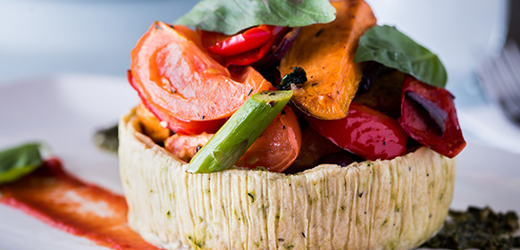

ROASTED BUTTERNUT SQUASH & SWEET POTATO TART
stuffed with roasted peppers, leeks, confit tomato, topped with Cropwell Bishop custard and Stilton & walnut crumb (v)
£11.50

BEER-BATTERED LINE-CAUGHT COD
with twice-cooked chunky chips, minted pea purée and tartare sauce
£13.75

LOBSTER & DEVON CRAB FISHCAKES
with asparagus, pea & truffle oil velouté topped with crispy seaweed and your choice of fries or salad
£13.95

SEARED SALMON FILLET
on Chorizo mash, tenderstem broccoli and Bouillabaisse sauce
£15.95

BATTERED HALLOUMI
with twice-cooked chunky chips, minted pea purée and tartare sauce (v)
£11.95

CHICKEN, LEEK AND CREME FRAICHE PIE
topped with ham hock crumb, served with kale mashed potato and buttered green beans
£14.95

CHARGRILLED LAMB KOFTAS
Goats’ curd, plum tomato, roasted red pepper, cucumber & mint salad with lavash bread
£14.95

PAN-FRIED SEA BASS FILLETS
with parmentier potatoes , panchetta,olives,spinach and white wine veloute
£17.95

BUTTERMILK SOUTHERN-FRIED CHICKEN
stuffed with 'nduja sausage, with sweet potato fries, apple salad and lemon aioli
£15.50

STEAKS & BURGERS
All our steaks are expertly aged for superb texture & flavour.

HOME-MADE BRITISH BEEF BURGER
with smoked Irish Cheddar, mustard mayonnaise, relish and fries
£13.95

WAGYU BURGER
with smoked Irish Cheddar, crispy onions, tomato relish, sweet potato fries and aioli
£16.95

9OZ RIB-EYE STEAK
with twice-cooked chunky chips, crispy onions, grilled mushroom, confit tomato and baby kale
£21.95

7OZ FILLET STEAK
with an ale-glazed shallot tart topped with Cropwell Bishop custard, Stilton & walnut crumb and twice-cooked chunky chips
£24.95

ADD ON

Peppercorn sauce
£1.95

Béarnaise sauce
£1.95

Beef dripping sauce
£1.95

King prawns & garlic butter
£3.95

Lobster & garlic butter
£8.95

SIDES

Tenderstem Broccoli, Asparagus & Green Beans in Soy glaze (ve)
£3.95

Classic Mac & Cheese (v)
£3.95

Dressed house salad (ve)
£3.50

Beer Battered Onion Rings (v)
£3.50

Sweet potato fries with Gran Moravia cheese & rosemary (v)
£3.95

Fries & aioli (v)
£3.00

Twice-cooked chunky chips (v)
£3.50

Dauphinoise potatoes (v)
£3.95

DESSERTS

THE HOUSE SHARER
Chocolate Brownie, Baked vanilla Cheesecake, Mango & Berry Meringue Mess, Bourbon vanilla ice cream cookie sandwich
£11.95

NEW YORK STYLE BAKED VANILLA CHEESECAKE
with a forest fruit compote and whipped cream (v)
£6.75

WARM BELGIAN CHOCOLATE BROWNIE
with Bourbon vanilla ice cream (v)
£6.75

VANILLA CREME BRULEE
served with home-baked sultana & oatmeal biscuits (v)
£5.95

MELTING CHOCOLATE & PEANUT BOMB
filled with sticky toffee pudding and peanut butter cream. Served with Bourbon vanilla ice cream & hot salted caramel sauce (v)
£7.95

MANGO, BERRY & COCONUT MERINGUE MESS
Crushed meringue, with mango, strawberries & passion fruit coulis, folded in a coconut sauce
£7.25

CHOCOLATE & RASPBERRY PUDDING
A silky chocolate sponge, filled with a raspberry compote middle. Served with Bourban vanilla ice cream (v)
£6.95

APPLE & BLACKBERRY CRUMBLE
topped with a Demerara crumb served with custard (v)
£5.95

PINEAPPLE TART TATIN
topped with mango and served with coconut milk sorbet (ve)
£7.25

STICKY TOFFEE PUDDING
with Bourbon vanilla ice cream (v)
£6.75

ICE CREAM & HOME-BAKED TRIPLE CHOCOLATE COOKIE
Choose three scoops from Bourbon vanilla, double chocolate, praline or strawberry (v)
£5.25

BRITISH CHEESE BOARD
Shepherd’s Purse Yorkshire Blue, Lubborn Somerset Camembert, Belton Farm Red Leicester, Isle of Man vintage Cheddar with a selection of Fudge’s nut & mixed seed biscuits, grapes, celery and chutney (v)
£7.95

MINI DESSERT & A HOT DRINK
Choose from Mini apple & blackberry crumble, mini baked vanilla cheesecake or mini Belgian chocolate brownie (v)
£4.95

