WHILE YOU WAIT
While we prepare your roast dinner enjoy a tasty Yorkshire bite.

Yorkshire bites
filled with tender beef and beef dripping gravy
4.25

Stone-baked flatbread
topped with garlic butter (V)
4.75
Add: Cheddar cheese £1.00

SHARERS & GRAZERS

Sticky platter
maple-glazed chicken wings, prawns & chorizo in garlic butter, lamb koftas, salt & pepper calamari and a stone-baked garlic flatbread
15.75

Mezze Platter
lentil falafels, spiced red pepper dip, breaded brie, tzatziki, duo of hummus and a spiced stone-baked flatbread (V)
10.95

Handmade dough sticks
served with garlic butter, pesto and a chipotle chilli mayonnaise (V)
5.50

Stone-baked flatbread
topped with garlic butter (V)
4.7

STARTERS

Chargrilled lamb koftas
served with tzatziki and dressed slaw
5.75

Pine nut & carrot falafal †
with a spiced red pepper dip and toasted ciabatta (VE)
5.50

Today’s soup
with rustic bread
4.50

Oven-baked button and Portobello mushrooms
in a garlic & mature Cheddar sauce, served with rustic bread (V)
5.25

Duo of pâté*
coarse pork & Madeira pâté and duck liver parfait with Bramley apple butter, blackcurrant curd, baby gherkins & rustic bread
5.95

Deep fried breaded brie
in a crispy panko crumb served with apricot chutney (V)
4.95

Salt & pepper calamari
with chorizo-flavour seasoning and chipotle chilli mayonnaise
4.95

Prawn & lobster cocktail*
dressed with lobster mayonnaise served with rustic bread.
6.25
Served with Yorkshire pudding, ruffled roast potatoes, thyme roasted carrots, roasted parsnips, seasonal greens and as much gravy as you like.

Roast sirloin of beef
prime sirloin with all the trimmings
11.95

Pork Belly
with a lemon & thyme stuffing wrapped in bacon
11.50

Slow-cooked lamb shank
seasoned with rosemary
13.50

Roast breast of turkey
with lemon & thyme stuffing wrapped in bacon
10.95
Add: An extra Yorkshire pudding £0.50 | Extra roast potatoes £2.50 | Cauliflower cheese £2.50 Lemon & \ Thyme stuffing wrapped with bacon £1.50

Roast beef duo - For One
roast beef alongside slow-cooked short rib of beef
14.75

Roast trio - For One
roast beef, roast breast of turkey and pork belly with lemon & thyme stuffing wrapped in bacon
12.75

PUDDINGS
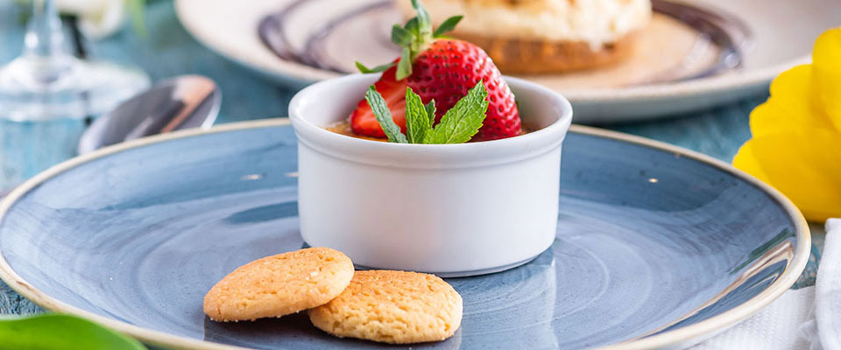

Classic vanilla crème brûlée (V)
5.25

Lemon Meringue Pie (V)
with raspberry coulis
5.25

Pudding tasting platter† (V)
8.95

Sticky toffee pudding*
5.50

Coconut Panna cotta style pudding (ve)
topped with passionfruit and fresh berries
5.95

Crumble of the day* (V)
5.75

Eton mess (V)
5.75

Bramley apple pie (V)
4.95

Rich banoffee pie (V)
6.50

British blackcurrant & Prosecco cheesecake*
with blackcurrants in sauce and an amaretto crumb
5.95

Toffee & butterscotch duo†
6.95

Belgian chocolate brownie* (V)
5.50

Trio of ice cream (V)
4.95

British cheeseboard*† (V)
7.95

HOT DRINK AND A MINI PUDDING - £4.95
Choose one of our hot drinks with one of these mini puddings (add a liqueur to your hot drink for an extra £1.35)
• Butterscotch créme caramel panna cotta
• Crumble of the day* (V)
• Toffee milk tart† (V)
• Eton mess (V)
• Belgain chocolate brownie* (V)
* = Contains alcohol.
† = Contains tree nuts and/or peanuts
(V) = made with vegetarian ingredients; (ve) = made with vegan ingredients, however, some of our preparation and cooking methods could affect this.
If you require more information, please ask your server.

